**Assignment 2: Instructions**

This is an individual assignment thus please be sure you have completed it on your own. It would be a great help if you review the HW G solution before starting this assignment. Be sure to use proper alignment with your indents. Be sure to name your file with your Last Name and then First Name submit **ONLY 1** document. YOU MUST USE SQLSERVER AND COPY/PASTE BOTH YOUR CODE AND DATA FROM THERE ONTO YOUR INSTRUCTION SHEET. **NOTE: DO NOT USE dbo. in any of your select/table SQL statements as it is not needed and only used to show that it is your database in SQLServer. Also, be sure to use NUMERIC and not MONEY for any currency fields.** The total value of points for this assignment is 105.

The Home Furnishings Company is a retail organization that provides products to the community.

**Part 1: Normalization**

The given entities for this exercise are: CUST, INV, and INV_ITEM

The following listing of attributes (listed in alpha order) are to be normalized into the given entities as listed above:

CustID, Email, FirstName, InvDate, InvID, Item, ItemNumber, LastName, Phone, Quantity, TotalAmount, UnitPrice

1. List the entities and the associated attributes in **sentence structure** (underline the unique identifiers). Do not show foreign keys. (4 points)

CUST (CustID, FirstName, LastName, Phone, Email)

INV (InvID, InvDate, TotalAmount)

INV_ITEM (ItemNumber, Item, Quantity, UnitPrice)

**Part 2: Data Model**

1. Create a Data Model of the sentence structures in Part 1 using Visio as follows: (6 points)

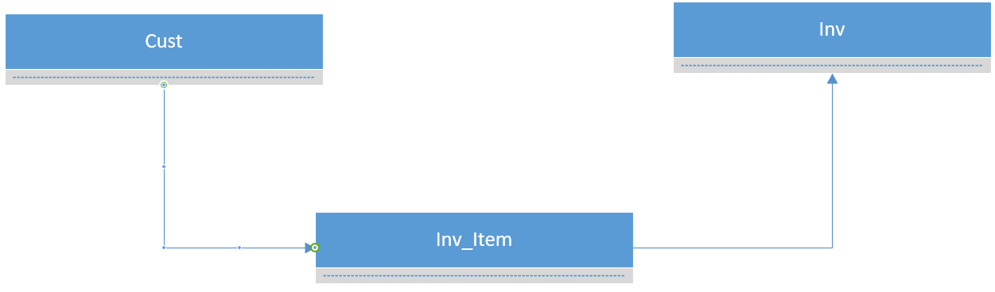

**Part 3: Database Design**

1. Create a database design based on Part 1 and Part 2 above by completing the template below:

(15 points)

-Be sure to include foreign keys where needed.

-Assume the CustID is a surrogate key starting at 1 and incrementing by 1.

-Assume the FirstName and LastName together constitutes an alternate key.

-Don’t forget the relationships

|  |  |  |  |  |
| --- | --- | --- | --- | --- |
| Table: CUST |  |  |  |  |
| **Column Name** | **Type** | **Key** | **NULL Status** | **Remarks** |
| CustID | Int | PK | NOT NULL |  |
| FirstName | Char(25) |  | NOT NULL | AK1.1 |
| LastName | Char(25) |  | NOT NULL | AK1.2 |
| Phone | Numeric(10) | AK | NOT NULL | AK2.1 |
| Email | Char(25) | AK | NULL | AK3.1 |
|  |  |  |  |  |
| Table: INV |  |  |  |  |
| **Column Name** | **Type** | **Key** | **NULL Status** | **Remarks** |
| InvID | Int | PK FK | NOT NULL |  |
| InvDate | DateTime |  | NOT NULL |  |
| TotalAmount | Numeric(8,2) |  | NOT NULL |  |
|  |  |  |  |  |
| Table: INV_ITEM |  |  |  |  |
| **Column Name** | **Type** | **Key** | **NULL Status** | **Remarks** |
| ItemNumber | Int | PK FK | NOT NULL |  |
| Quantity | Int |  | NOT NULL |  |
| UnitPrice | Numeric(8,2) |  | NOT NULL |  |
| Item | Char(50) |  | NOT NULL | AK1.1 |

|  |  |  |  |  |
| --- | --- | --- | --- | --- |
| Table: CUST_ORDER |  |  |  |  |
| **Column Name** | **Type** | **Key** | **NULL Status** | **Remarks** |
| OrderItemNumber | Int | PK | NOT NULL | Surrogate key, binned to accommodate multiple items in customer order. IE Order 1 is #1000-1999, with each integer included in range being an item |
| ItemNumber |  |  | NOT NULL |  |
| QuantityOrdered |  |  | NOT NULL |  |
| CustID | Int |  | NOT NULL |  |
| TotalPrice | Numeric(8,2) |  | NOT NULL |  |

**This seemed like the most elegant solution to me.**

|  |  |  |  |  |
| --- | --- | --- | --- | --- |
| **Relationship** | | **Cardinality** | | |
| **Parent** | **Child** | **Type** | **MAX** | **MIN** |
| INV_ITEM | INV | ID Dep | 1:N | O-M |
| CUST | CUST_ORDER | ID Dep | 1:N | O-M |

1. Use the following database design to create an ERD in Visio to include: (6 points)

* All tables, fields, and relationships.
* Be sure to include foreign keys and all the data shown in the design below.

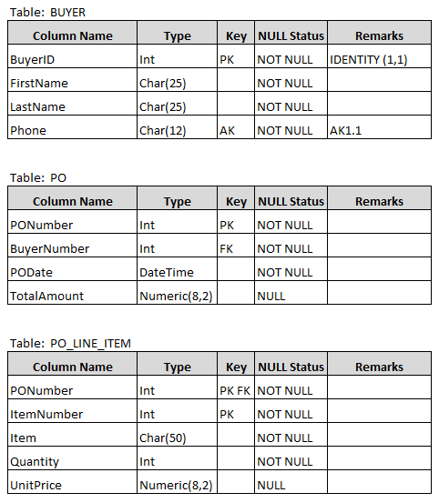

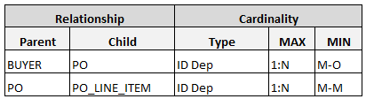

Visio Solution:

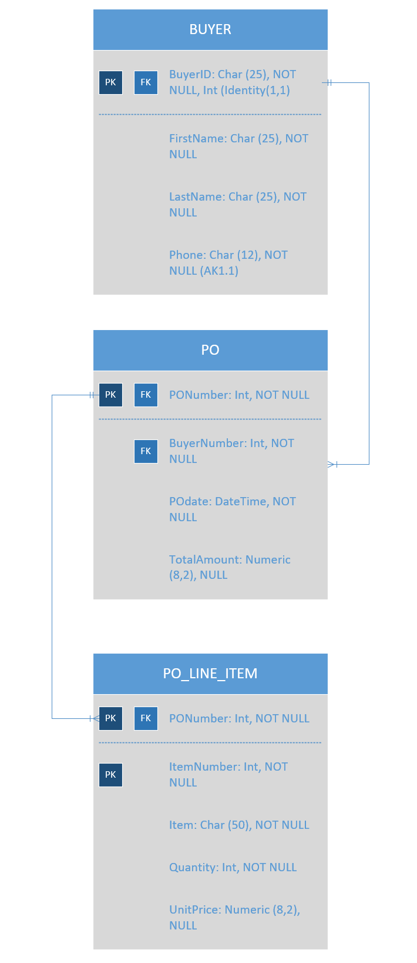

**Part 4: Data Manipulation**

**NOTE**: **All code and data MUST be copy and pasted from SQLServer for credit.**

All code must be properly indented as seen in the textbook and solutions to homework and assignments.

This section deals with SQL coding of data and is referred to as the DML (Data Manipulation Language) portion of a database. Copy/Paste the code from SQLServer and then copy/paste the data results. (**if more than 10 records just show the first ten**). A deduction of 1 point will be made if more than 10 records are shown. Please follow the instructions below.

**Pirate Sports (PS) Tables:** The tables below will show the fields of each table that you will use.

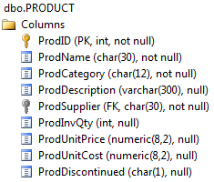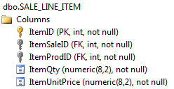CUST SALE_LINE_ ITEM PRODUCT

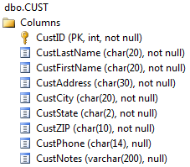

SUPPLIER SALE

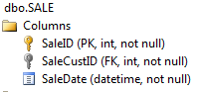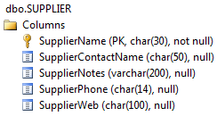

**IMPORTANT NOTE: Only string together fields when requested. The phrase “string together” will be used for ONLY those fields you are to string together. Also, be sure you understand the following differences.**

* When referring to “sales” always be sure to obtain data from the SALE and ITEM tables
* When referring to “inventory” or “value” always be sure to obtain data from the PRODUCT table.
* When referring to “profit” it will always be (Price – Cost)
* When referring to “value” it will always be (Quantity * Price)
* Be sure to show both the code and results (ONLY 1ST 10 RECORDS) copy and pasted from SQLServer
* When referring to “Pirate Sports” it means the company for the database, not a supplier
* When the word “total” is used it refers to all the items together
* Include ONLY those fields that are requested, no more

**Section 1** (Each question counts as 5 points)

1. List all information on each customer and sort by state, city, and then last name.

CODE:

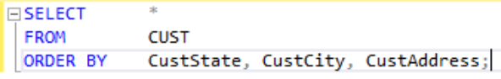

DATA:

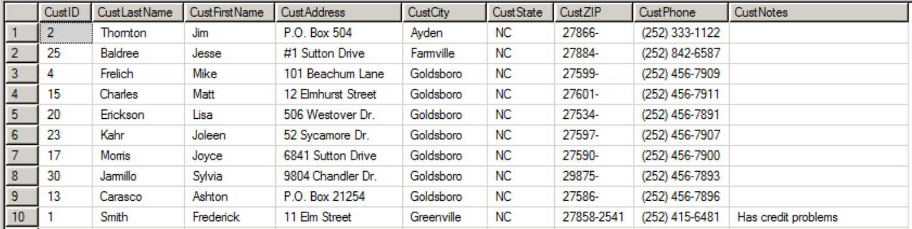

1. List all products, their descriptions, their category, the inventory quantity, the selling price, and the supplier that is carried by Pirate Sports. Sort by supplier and then the product name.

CODE:



DATA:

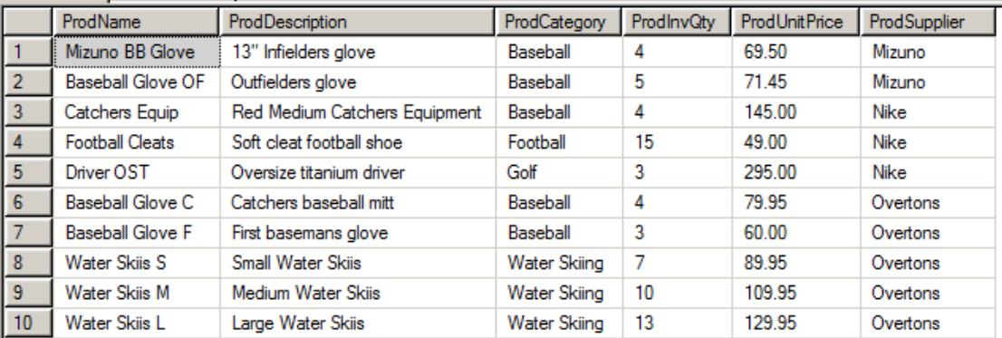

1. List all tennis and golf products that have a selling price of over $100. Include the product name, selling price, supplier and sort by category and then by price in descending order.

CODE:

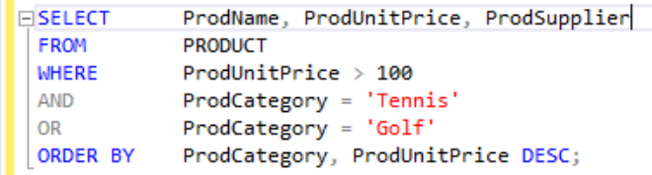

DATA:

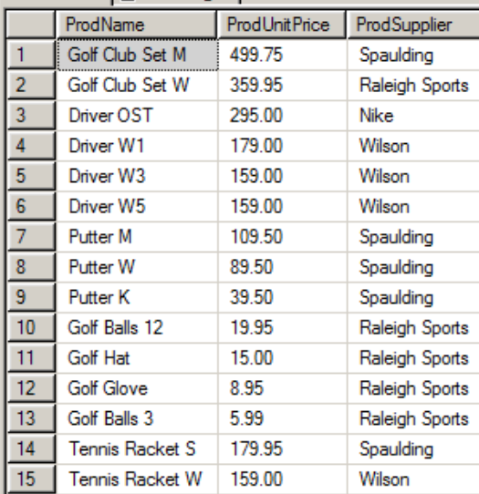

1. List all products (name of the product, supplier, category, and inventory quantity) that have an inventory quantity of 4 or more except those products supplied by Spaulding. Sort by supplier and then by inventory quantity.

CODE:

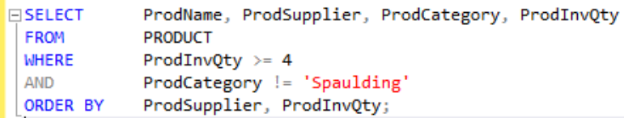

DATA:

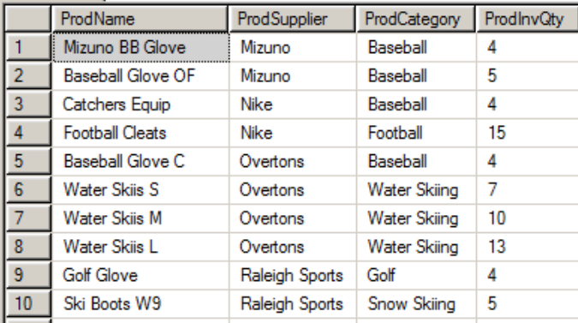

1. List the highest unit price, and the lowest unit price, and the average unit price for all products together except tennis.

CODE:



DATA:

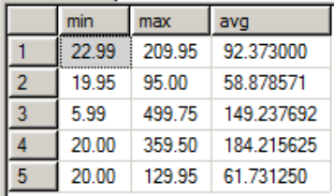

1. List all products and their descriptions where “ski” is used within the description.

CODE:

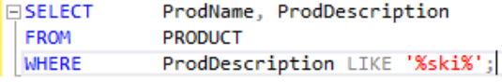

DATA:

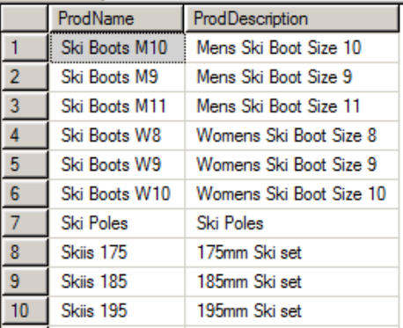

1. Show the total value for all products in inventory.

CODE:



DATA:

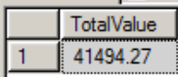

**Section 2** (Each question counts as 6 points)

1. String together each product name and the supplier so that it looks like “LL Baseballs are supplied by Wilson” and name the new field ProdSupplier.

CODE:



DATA:

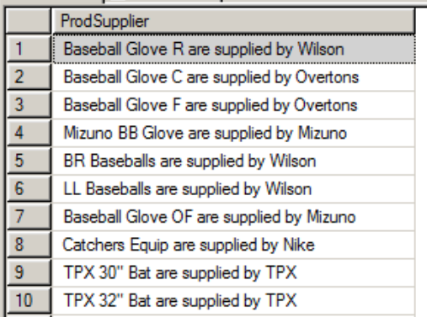

1. Show the total inventory value and total inventory cost for all products supplied by Nike. Name the new fields TotalInvValue and TotalInvCost respectfully.

CODE:



DATA:

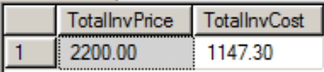

1. List every customer (last name then first name) and the city they are from who has purchased any product. Do not show duplicate names and sort by their city of residence and then their last name.

CODE:

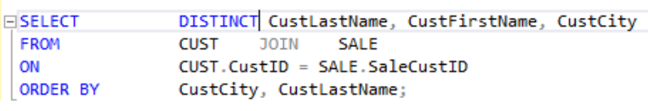

DATA:

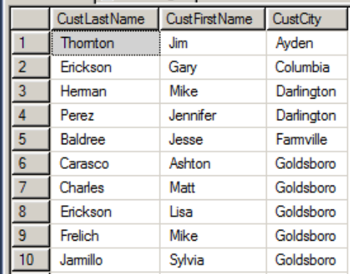

1. List the supplier and supplier contact name along with all the products they supply. Sort by supplier name.

CODE:

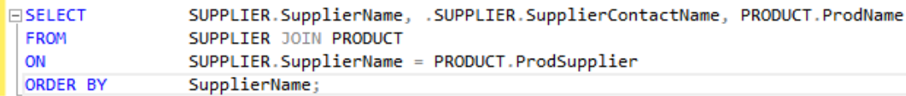

DATA:

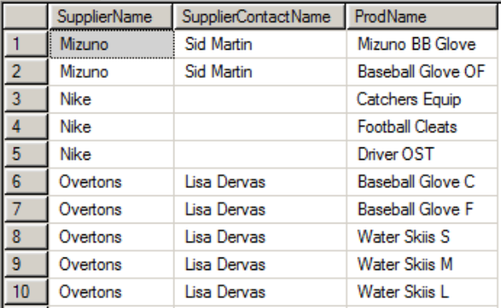

**Section 3** (Each question counts as 7 points)

1. List all products that have an inventory total cost between $600 and $900. Include the product name and total inventory cost and sort by inventory cost beginning with the highest inventory amount.

CODE:

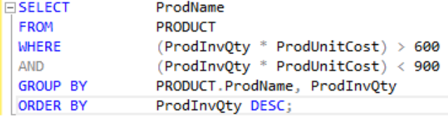

DATA:

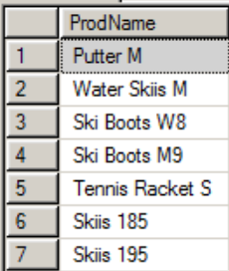

1. Show the product category and the total potential profit (by product category) if all items in inventory were sold.

CODE:



DATA:

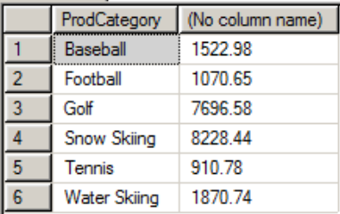

1. List all products, their product category, and unit selling price as a string so that those fields are included in the following statement: “The (product) is in the (category) category and sells for (unit price).” When done it should look like: (as an example) “The catcher’s glove is in the baseball category and sells for $35.00.”

CODE:



DATA:

